Geologic Hazards Report
Name
Institutional Affiliation

Geologic Hazards Report
Part 1: Geologic Hazards
Geological hazards should always be considered first before deciding to purchase a property. This is because they can cause damage to property, injuries, and even death. Geological hazards that need to be investigated include volcanic, earthquake, flood, landslides, severe weather risk, human-created threats, and soil stability among others. This should be done by reviewing historical data and scientific forecasts to make an informed choice about the location.
Part 2: Geologic Hazards Report
The Location
I have always wished to live in Arizona. This area has a moderate climate, with few environmental hazards, and relatively secure with no registered offenders. I would like to purchase my house at the following address: 11333 N Scottsdale Rd Suite 100, Scottsdale, AZ 85254, United States.
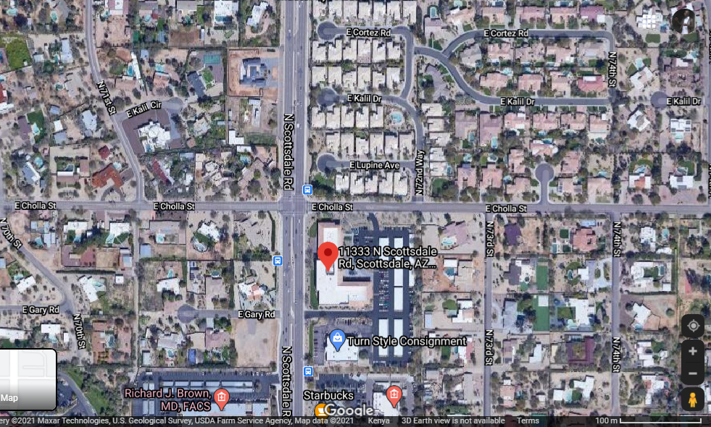
Fig 1: Location of the Property. Source: Google (n.d.)
Analysis of the Individual Risk
  - Volcanic Risk
The state of Arizona experienced volcanic activities about 800 years ago (Harris and Pearthree, n.d.). Currently, there are no active volcanic activities likely to happen soon. Underground studies indicate that there are no magma movements beyond SFVF indicating that the probability of an occurrence of volcanic activity soon is nearly zero. Nevertheless, active volcanic activities in the nearby states can affect the site by depositing heavy asses on a rooftop that can damage houses or increase gaseous compounds to the air thus risking the health of the inhabitants of Arizona. The nearest active volcanic area is located about 1235 KM away which is the caldera region located in the Long Valley. Despite showing signs of active volcanic activity, the probability of volcanic activity in the caldera affecting other states is exceedingly small.
  - Earthquake Risk
According to Harris and Pearthree, (n.d.) Arizona has experienced numerous catastrophic earthquakes categorized as low or moderate earthquakes in the past century. In the last one hundred and fifty, Arizona has experienced 20 or more earthquakes among them the 7.4 magnitude earthquake that struck Sonoran killing fifty-one and causing extensive damage, (U.S. Geological Survey 2017). Nevertheless, various regions in Arizona can be categorized depending on their history of the earthquake, number, and slip rate of identified active faults. Areas near my dream house are considered to have little likelihood of experiencing earthquakes due to the little historical seismicity as well as an absence of young faults.
  - Flood Risk
Arizona is an arid area that experiences little rain. However, the area may experience intense rainfall causing a widespread flood that may result in flooding. The thin soil covering many parts of Arizona has little capacity to soak excess water which results to flood. Even though all parts of Arizona are prone to flooding, areas near the rivers are more prone to disastrous floods. The area near our site has no river flowing which means it is safer than other parts of Arizona that are near rivers.
  - Landslide/Mass Movement Risk
Arizona experiences land movements such as landslides caused by human and natural activities. Floods and earthquakes intensify cases of a landslide as the land is hilly with loose rocky materials, (Carlson, Carnes and Cook, 2019). On the other hand, human activities such as mining and construction of houses on the top of the mountain increase the risk of landslide. Nevertheless, it seems our location is a bit safer than other places in Arizona as it is fairly flat and less prone to earthquakes and floods. It is thus not likely to experience a landslide.
  - Severe Weather Risk (Hurricanes, Drought, Tornados, etc.)
The weather in Arizona is hot and dry which causes drought (Drought risk atlas - Maps and station data. (n.d.). Weather patterns especially in early fall and late summer can cause hurricanes as well as tropical storms to affect Arizona, (Harris, and Pearthree, n.d.). This can result to flood and other disastrous effects of stormwater.
  - Human-Created Toxic Hazards (Superfund Sites, Toxic Spills, Lead Contamination, Etc.)
Arizona has fairly fresh air. However, according to (Harris, and Pearthree, n.d.), the air quality has been declining over the past years as illustrated in the figure below.
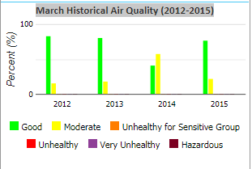
Fig 2: Air quality from 2012 to 2015 in Arizona. Source: US Environmental Protection Agency. (n.d.).
Several human-created hazards exist in Arizona. They include open and abandoned mines which pose a threat to fall and breeding of mosquitoes which can cause malaria. The area can also be used as a hind out for bandits that can pose a security threat to the area, (Harris, and Pearthree, n.d.). Nevertheless, the near the desired place has been converted into real estate thus creating a solution for this threat.
  - Any Other Risks You Encounter:
Problem soils
The soil in Arizona is problematic such as expansive and crackly clay soil (Harris, and Pearthree, n.d.). The soil can be modified by applying hydrated lime to reduce expansion. The expansive soil can also be removed and replaced with non-expansive soil.
The Total Risk of the Property
The property faces many risks due to its geological location. However, the chosen area appears to be safer than other parts of Arizona. The area has less exposure to floods, earthquakes, landslides, and severe weather risks which make it a relatively habitable area. The area is nevertheless faced with expansive soil that can risk cracking and destroying houses. Luckily, the soil can be removed and replaced with a better one or be treated using hydrated lime.

References
Carlson, G., Carnes, L. K., & Cook, J. P. (2019). Exploring Arizona earth fissures: An anthropogenic geologic hazard. Geologic Excursions in Southwestern North America, 55, 115.
Drought risk atlas - Maps and station data. (n.d.). NOAA Climate.gov | science & information for a climate-smart nation. https://www.climate.gov/maps-data/dataset/drought-risk-atlas-maps-and-station-data
Google. (n.d.). [11333 N Scottsdale Rd]. Retrieved March 6, 2021, from https://www.google.com/maps/place/11333+N+Scottsdale+Rd,+Scottsdale,+AZ+85254,+USA/@33.7226405,-112.0544091,11z/data=!4m5!3m4!1s0x872b74f27fa35977:0x1613cbdeb8672d18!8m2!3d33.5887178!4d-111.9255313
Harris, R. C., & Pearthree, P. A. (n.d.). A Home Buyer's Guide to Geologic Hazards in Arizona.
US Environmental Protection Agency. (n.d.). The United States Environmental Protection Agency | US EPA. https://www3.epa.gov/myem/envmap/find.html
U.S. Geological Survey. (2017). USGS.gov | Science for a changing world. https://www.usgs.gov/natural-hazards/earthquake-hazards/hazards#2017

